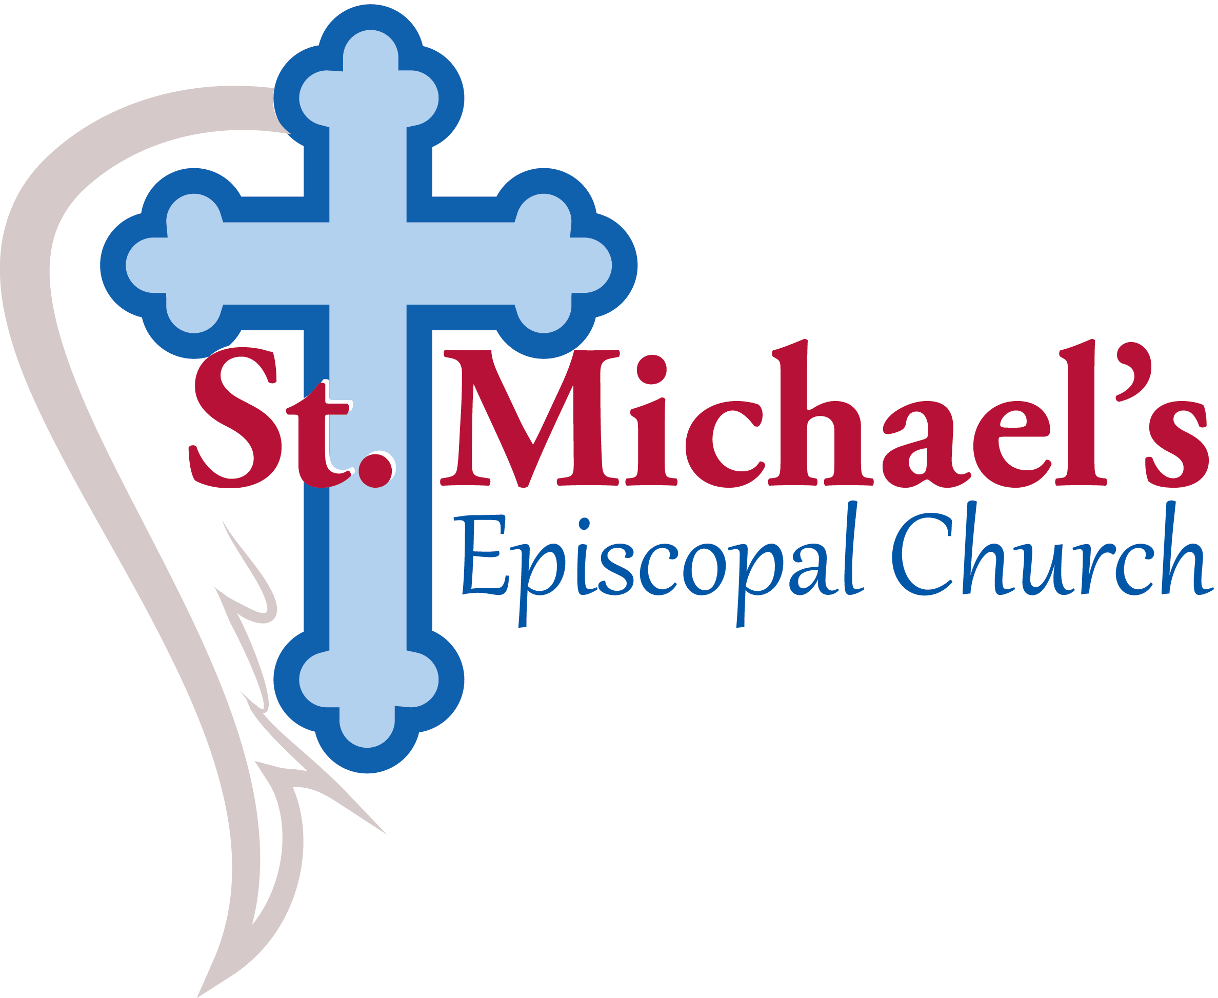  Welcoming all to a relationship with God through Christ; serving in our community.  1200 Powdersville Rd.  Easley, SC 29642  (864)859-6296 | 2025 Stewardship Commitment  January through December 2025  In gratitude for God’s love in Jesus Christ, and to support the mission and ministry of St. Michael’s  Name(s): ________________________________________________________________  pledge to give  $_________________________  Per Week / Per Month / Per Year  (please circle one)  For all things come from you, and of your own have we given you.  1 Chronicles 29:14b

